Solution Architecture
(Incident Lifecycle Management System)
Date | 21 October 2026
Team ID
Project Name | Incident Lifecycle Management System in ServiceNow
Maximum Marks | 4 Marks

Introduction
Solution architecture bridges the gap between a business problem and its technology solution. For the Incident Lifecycle Management System, it defines how users, ServiceNow interfaces, workflow automation, business logic, data storage, integrations, reporting and infrastructure work together to manage IT incidents from creation to closure.
In many organizations, incidents reported through emails, calls or spreadsheets are lost, delayed or handled without priority. The proposed architecture uses ServiceNow as one central platform so that every incident follows the same controlled lifecycle: New, In Progress, On Hold, Resolved and Closed.

Objectives of the Solution Architecture
Provide a clear technical structure for the proposed solution.
Map business requirements to ServiceNow platform components.
Define incident creation, assignment, resolution and closure data flows.
Support security, auditability, scalability and maintainability.
Provide extension points for future enterprise integrations.

Scope of the Solution
Incident logging through the Service Portal, Now Mobile app and email.
Automatic priority setting, categorization and assignment to the right support group.
SLA tracking with escalation and stage-wise email notifications.
Resolution, closure and auto-closure of resolved incidents.
Reports and dashboards for status, SLA and workload, with a full audit history.

High-Level Solution Architecture
The following diagram presents the proposed architecture of the Incident Lifecycle Management System.
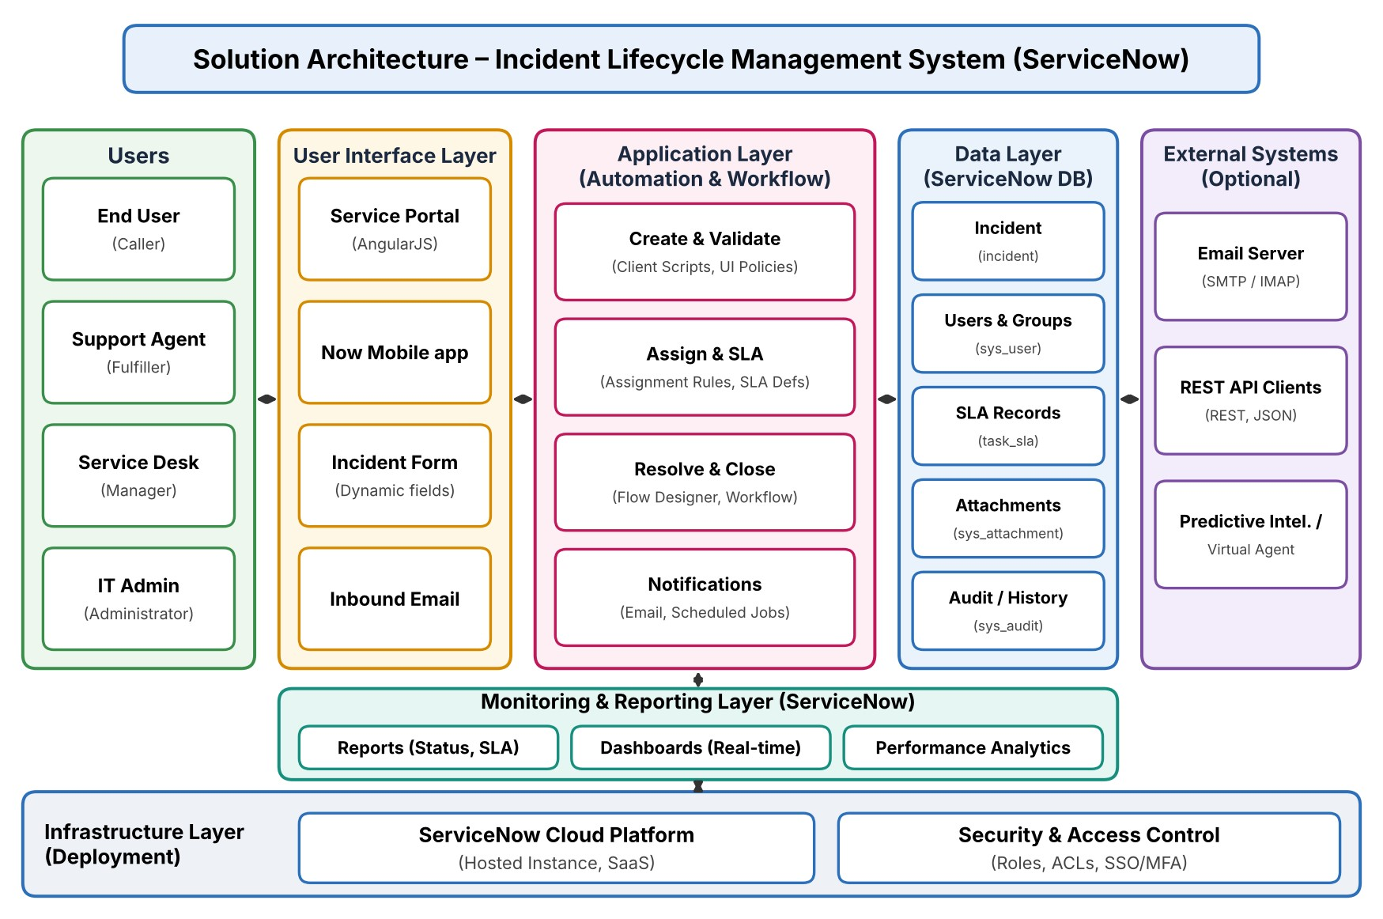
Figure 1: High-Level Solution Architecture

Architecture Description

User Layer
Includes End Users (callers who report incidents), Support Agents (fulfillers), the Service Desk Manager and IT Administrators. Each role accesses only the functions required for its responsibilities.

User Interface Layer
The ServiceNow Service Portal and the Now Mobile app provide the user interface, and incidents can also be raised by email. The incident form provides standardized, structured fields with dynamic behavior.

Application Layer – Automation & Workflow
Client Scripts and UI Policies support form behavior and validation. Business Rules set defaults and priority at incident creation. Assignment Rules route incidents to the right group, and SLA Definitions track response and resolution time. Flow Designer and Workflow automate resolution, closure and notifications, and Scheduled Jobs handle time-based actions such as auto-closing resolved incidents.

Data Layer
The ServiceNow platform database stores incident records (the incident table, which extends the task table), user and group records, SLA records, attachments and audit/history information.

External Systems
Optional integrations include the email server (SMTP/IMAP) for inbound incidents and notifications, REST API clients for third-party systems, and Predictive Intelligence / Virtual Agent where used.

Monitoring & Reporting
Reports, dashboards and Performance Analytics provide visibility into incident status, SLA performance, agent workload and operational trends.

Infrastructure & Security
The solution is hosted on the ServiceNow cloud platform as a hosted instance (SaaS), so no local server is required. Roles, ACLs, authentication (SSO and MFA) and audit logs provide controlled access and auditability.

Architecture Components and Functions
Layer / Component | Key Functions
Users | Report incidents, resolve incidents, monitor performance and manage configurations.
Service Portal / Now Mobile | Provide access to incident forms and status tracking on web and mobile.
Incident Form | Provides standardized incident fields, categories and attachments.
Client Scripts & UI Policies | Control form behavior, mandatory fields and dynamic fields.
Business Rules | Set defaults and priority and apply server-side logic at creation.
Assignment Rules & SLA Definitions | Route incidents to the right group and track response and resolution time.
Flow Designer & Workflow | Automate resolution, closure, escalation and notifications.
ServiceNow Database | Stores incidents, users, groups, SLAs, attachments and audit information.
External Integrations | Email server, REST API clients and optional Predictive Intelligence / Virtual Agent.
Layer / Component | Key Functions
Reports & Dashboards | Provide incident, SLA and performance visibility.
Security | Roles, ACLs, authentication and authorization protect access.
Infrastructure | ServiceNow cloud platform hosts the proposed solution.

Incident Processing Flow
Caller → Service Portal / Mobile / Email → Incident Form → Validation → Priority and Assignment → SLA Tracking → Resolution → Status Update → Notification → Closure → Audit / Reporting.

Architectural Benefits
Standardized incident intake from every channel.
Reduced manual coordination through workflow automation.
SLA tracking with automatic escalation.
Role-based access and full auditability.
Improved incident visibility and reporting.
Scalable addition of categories, workflows and integrations.

